 |  | SR UNIVERSITY  Campus Warangal
 |  | Program: II - B. Tech (CS& AI) Batch: 15
Name:N.Sathwika
Reg. No: 2503A52437
 |  | Department: Computer Science and AI Semester: I
 |  | AI Assisted Coding-Assignment Date: 22/09/2026

Q1– AI-Assisted Bubble Sort Analysis

numbers = [64, 34, 25, 12, 22, 11, 90]
TODO:
  - Implement Bubble Sort in ascending order.
  - Count comparisons and swaps.
  - Display the sorted list. Student Tasks:
- Implement Bubble Sort.
- Use AI to explain one complete pass of Bubble Sort.
- Count comparisons and swaps.
- Test at least three input lists.
- Ask AI about an early-exit optimisation.
- Compare the original and improved versions.

PROMPT:
“Explain Bubble Sort step by step for the given list. Identify opportunities to reduce unnecessary comparisons. Do not write the complete program yet.”

Code : numbers = [64, 34, 25, 12, 22, 11, 90]

CODE:
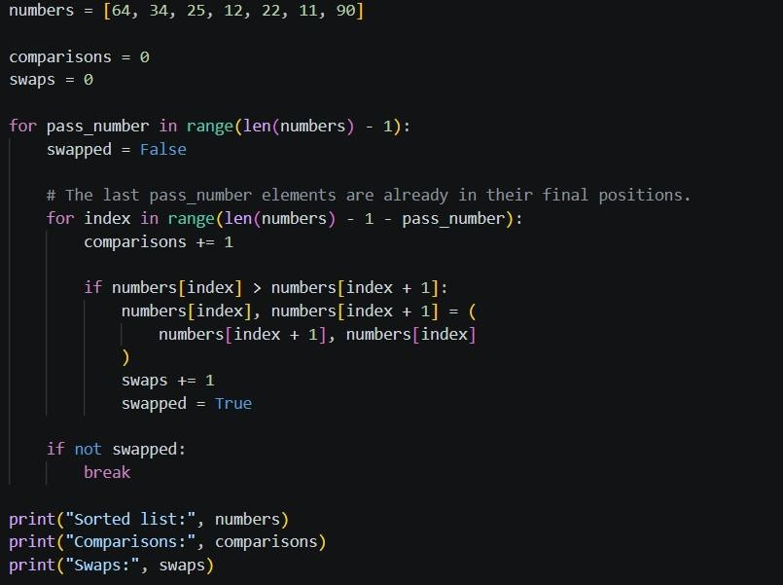

OUTPUT:
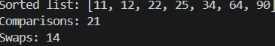
OBSERVATION:
Bubble Sort successfully sorts the given list in ascending order by repeatedly comparing and swapping adjacent elements. The early-exit optimization reduces unnecessary comparisons when the list becomes sorted.

Q2 – Linear Search vs Binary Search

PROMPT:
“Compare Linear Search and Binary Search for the given sorted list [5, 12, 18, 23, 31, 45, 56, 72, 89]. Explain why Binary Search requires sorted data, count the comparisons for both methods, and test first, middle, last, and absent elements.

Suggest one valid optimization.”
Code: earch_numbers = [5, 12, 18, 23, 31, 45, 56, 72, 89]
search_target = 45

CODE:

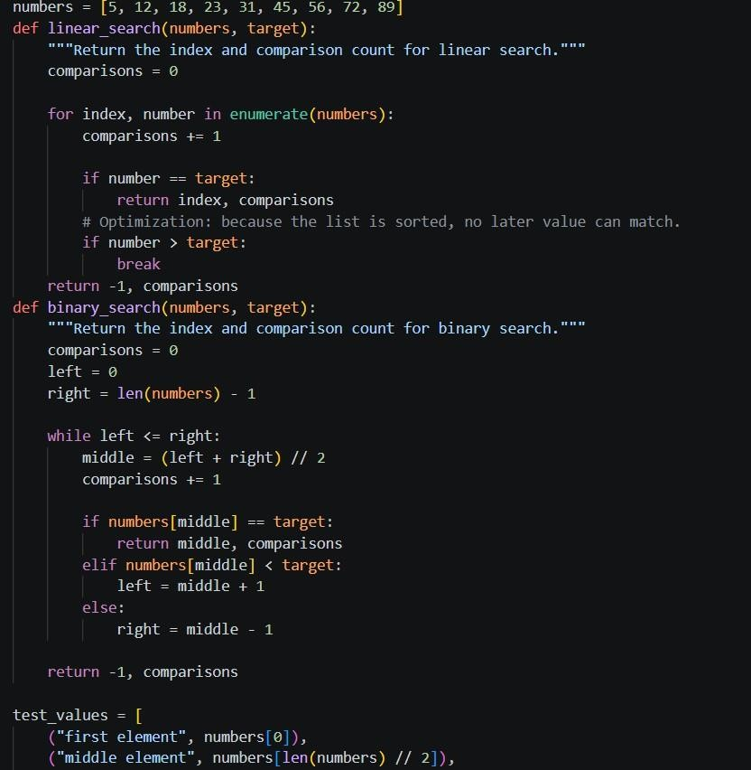

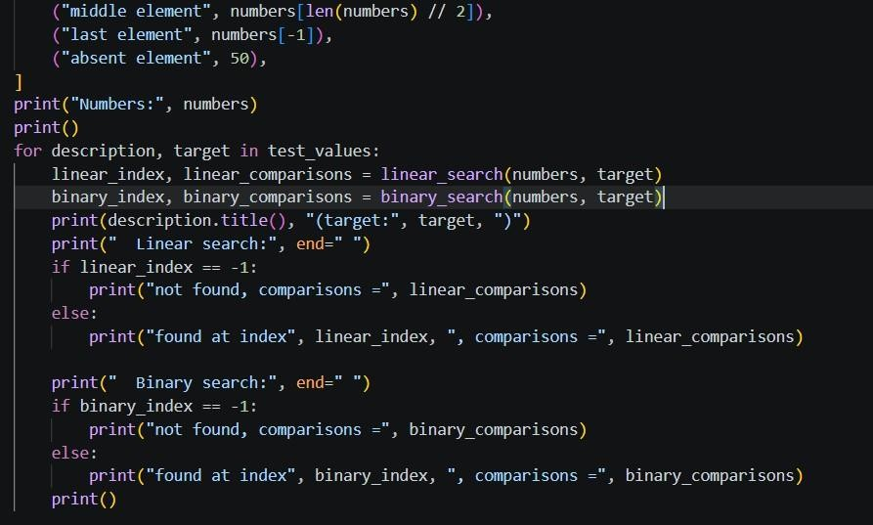
OUTPUT:
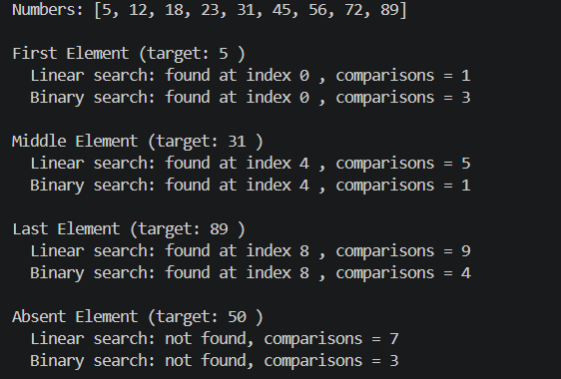

OBSERVATION:

Linear Search checks elements sequentially, while Binary Search repeatedly divides the sorted list into halves.
Binary Search generally requires fewer comparisons, especially for larger sorted datasets. The choice depends on whether the data is sorted and how frequently searching is performed.

Q3: Compare Sorting Algorithms

PROMPT:
“Compare Bubble Sort, Selection Sort, and Insertion Sort using the given list [45, 12, 78, 34, 23, 89, 5, 67, 10, 56]. Count their comparisons and swaps/shifts, explain their strengths and weaknesses, and identify which algorithm is most

suitable for nearly sorted data. Compare the results with their theoretical time complexities.”

CODE:

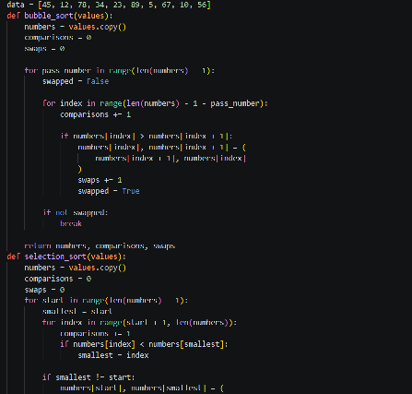

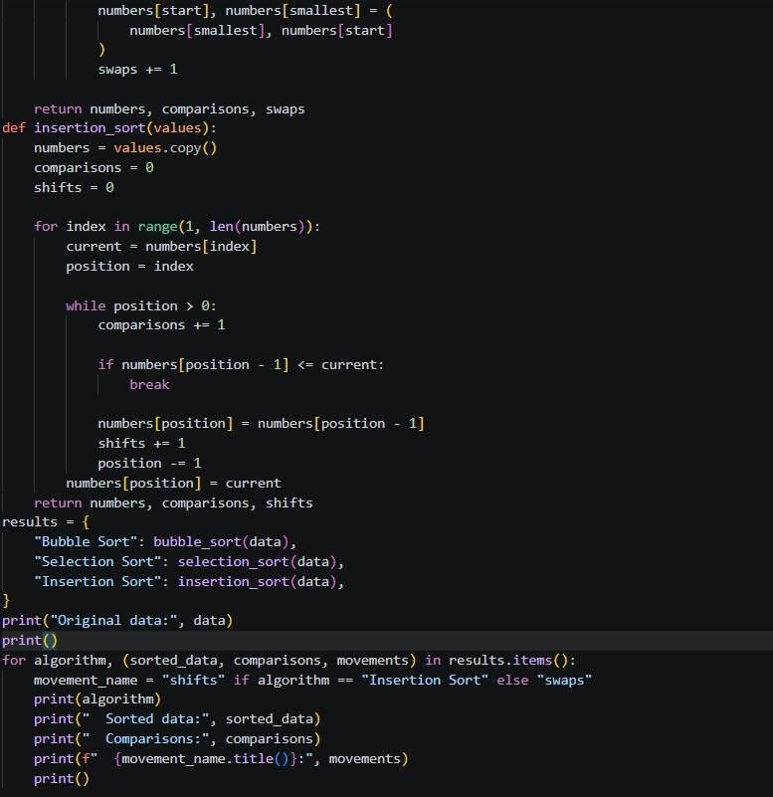
OUTPUT:

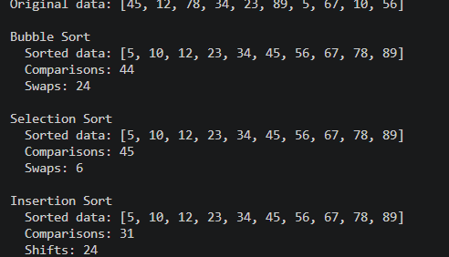
OBSERVATION:
All three algorithms successfully sort the same input list, but their comparisons and swaps/shifts differ.
Insertion Sort is generally more efficient for nearly sorted data because it requires fewer shifts.
The experimental results can be compared with the theoretical O(n²) time complexity of these algorithms.
- - - - - - - - - - - - - - - -

Q4 : Optimising a Student Search and Sort Program
PROMPT:
“Analyze the student records [("Arun",82), ("Bala",65), ("Chitra",91), ("Divya",74), ("Esha",88)]. Create functions to find the highest mark, sort students by marks, and search by name. Identify unnecessary operations and suggest an efficient approach, then compare the time complexity of the original and improved solutions.”

CODE:
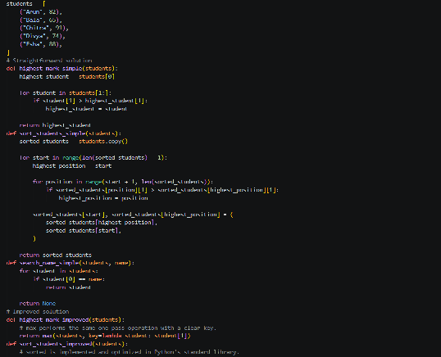

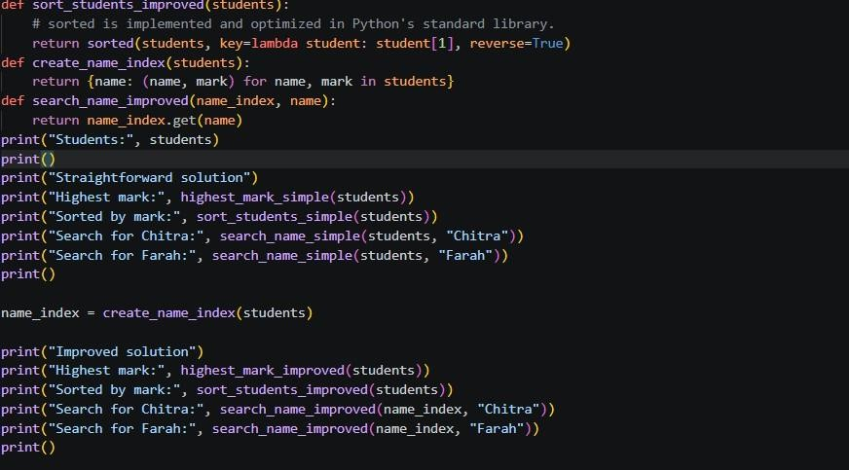

OUTPUT:
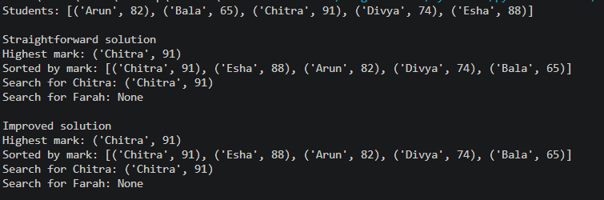

OBSERVATION:

avoid scanning the list again for every repeated name search; build a dictionary once, changing each later search from O(n) to O(1) average. Both versions sort in O(n log n), while the one-pass highest-mark scan is O(n). The improved approach uses O(n) extra space for the name index; the basic approach uses O(1) extra search space and is fine for occasional lookups.
The program successfully finds the highest mark, sorts the students, and searches for a student by name.
The improved approach can reduce unnecessary repeated operations by using suitable data structures and efficient searching.
The original and improved solutions can be compared based on their time complexity and number of operations.

Q5: Optimisation Challenge: Best Combination

PROMPT:

“For the given items and budget of ₹50,000, find the combination of items with the maximum total price without exceeding the budget. Compare Brute Force, Greedy, and Dynamic Programming approaches, identify which method guarantees an optimal solution, and explain its time and space complexity. Test the solution with at least three different budgets

CODE:
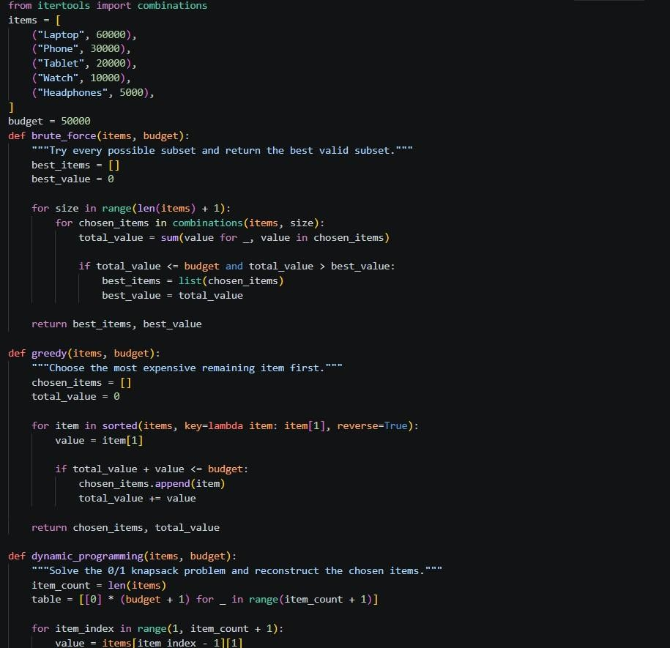

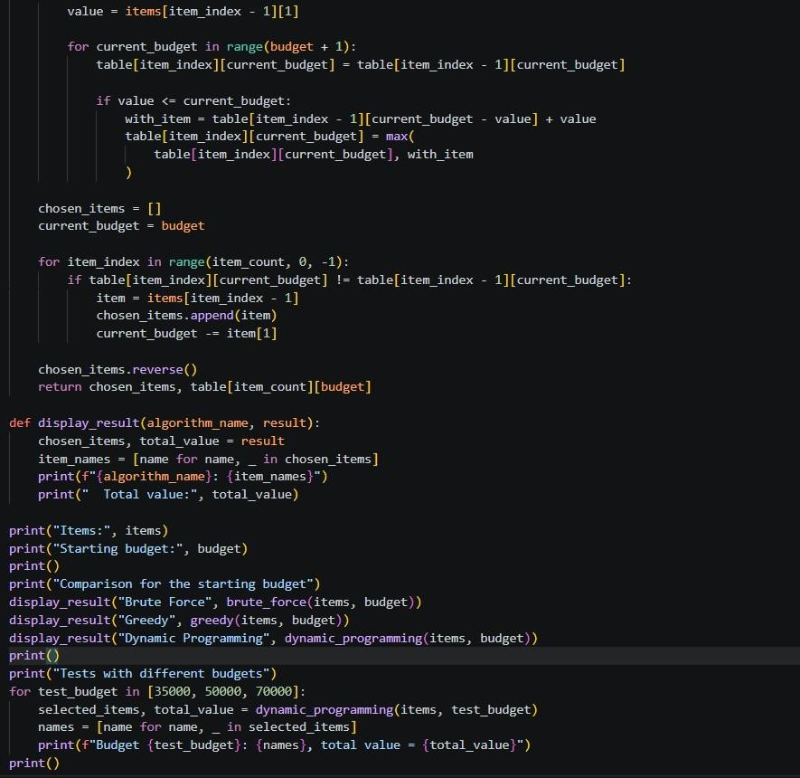

OUTPUT:

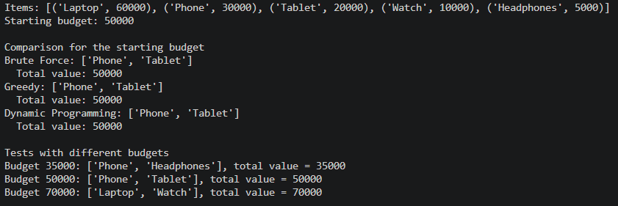

Observation:
The goal is to maximize the total item value without exceeding the given budget. Brute Force and Dynamic Programming can guarantee an optimal solution, while Greedy does not always guarantee the best combination.
Dynamic Programming is more efficient than Brute Force for larger inputs, but requires additional memory

